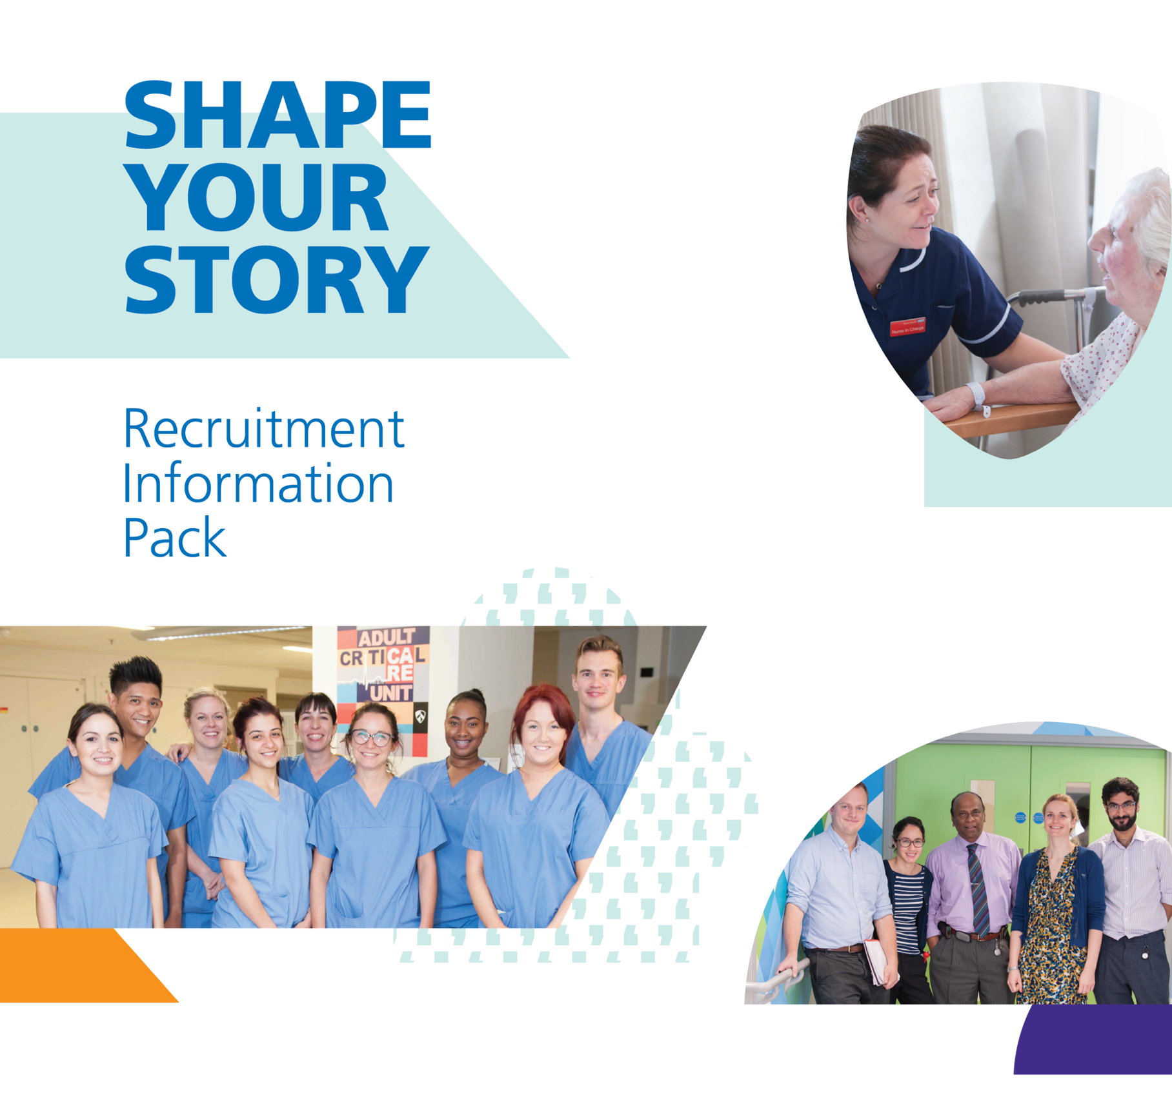

BARTS HEALTH NHS TRUST

DEPARTMENT OF OBSTETRICS AND GYNAECOLOGY

ROBOTIC SURGERY SITM FELLOW
(O&G ST5-7)

ROYAL LONDON HOSPITAL
WHIPPS CROSS HOSPITAL

The Trust

Barts Health NHS Trust was established on 1 April 2012, bringing together three hospital Trusts: Barts and The London NHS Trust, Whipps Cross University Hospital NHS Trust, and Newham University Hospital NHS Trust.

The trust is one of the largest in the UK, with over £1.2 billion in turnover and a workforce of more than 15,000 staff. By becoming a single trust, we now draw on the extensive expertise and best practices from our legacy trusts, creating a truly world-class health organisation.
Apart from the clinical benefits for patients and the financial advantages of the merger, there are also benefits for staff. These include access to enhanced training programmes (including, for some, the chance to gain experience in different hospitals), more opportunities for career development, and the chance to work alongside some of the best doctors, healthcare professionals, and researchers in their fields as part of a strong academic health science system. This will also enable senior staff to develop their expertise in innovative research, new techniques, and treatments to improve patient care.

We operate under a group operating model, with their own team managing each of the four hospitals.

Vision and Values

Barts Health Cares outlines the key points of our operating plan for the future. It highlights the topics we will focus on as we work with partners on a strategic 10-year plan for North East London as a whole.
Our Quality strategy aims to achieve this using our distinctive We Improve approach to measurable, staff-led change and supported by seven strategic plans: people, We Belong Inclusion strategy, research, education, finance, estates, informatics, and transformation.
Our five to ten-year strategy is supported by detailed plans for our clinical support services and each of our hospitals, including the redevelopment of Whipps Cross and a life sciences centre in Whitechapel. We also have a range of cross-cutting clinical board objectives, including our future plans for surgery and surgical strategy.
Our vision: to be a high-performing group of NHS hospitals, recognised for excellence and innovation, delivering safe and compassionate care to our patients in east London and beyond.
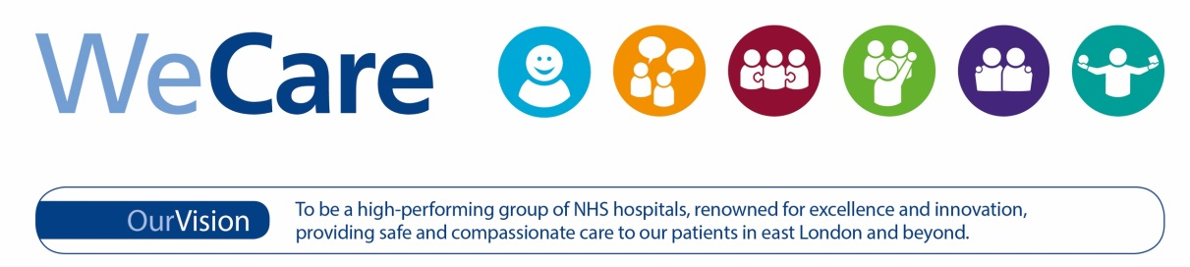

WeCare about our ambition for excellence
Our WeCare values shape everything we do, every day. They are evident in every interaction with each other, our patients, their families, and our partners.

We Care about everything from the appointment letters our patients receive to the state of our facilities when they walk through the door and the care and compassion they receive upon discharge. We Care that the people who join our trust share our values, so these values are embedded in our recruitment and selection processes. We Care that you feel valued while working here, so our values also guide our training, development, performance, and talent management. We Care about working with suppliers who share and embody our values.

We have made significant progress on our journey to provide safe and compassionate care. By adopting these values as our standard behaviour, we will realise our goal of excellence.
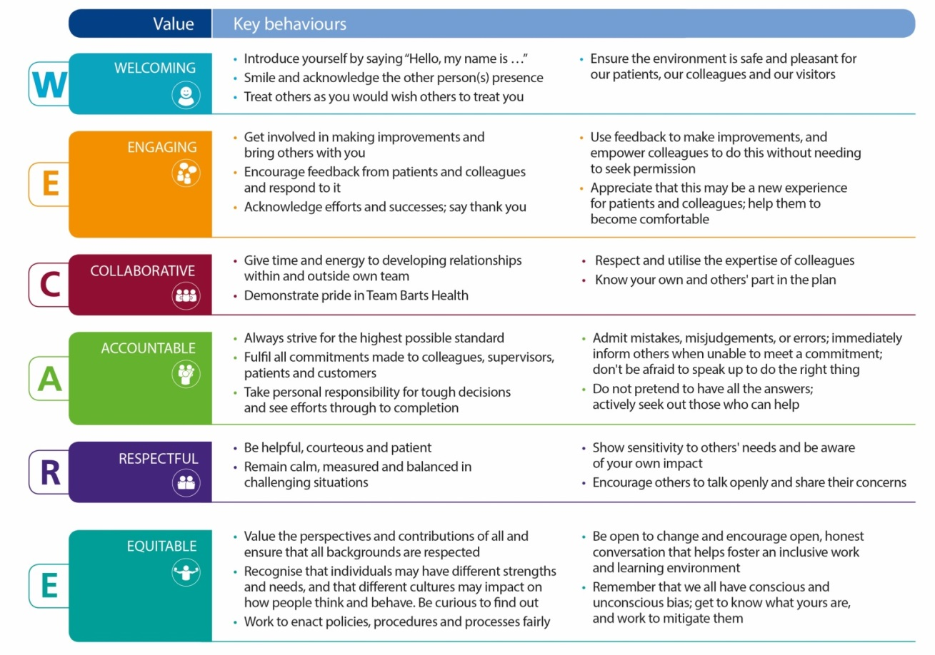
Job Overview

Job Title | Robotic Surgery SITM Fellow (O&G ST5-7)
Duration | 2 years
Base Hospitals | Year 1 - Royal London Hospital (RLH)  Year 2 - Whipps Cross Hospital (WXH)
Lead Supervisors | Mr Michael Wong, Consultant Gynaecologist, RLH  Ms Mehrnoosh Aref-Adib, Consultant Gynaecologist, WXH
Clinical Directors | Ms Charlotte Chaliha, Consultant Gynaecologist, RLH  Mr Fredric Willmott, Consultant Gynaecologist, WXH

- Job Purpose

This fellowship offers a comprehensive two-year curriculum designed to provide mastery in benign robotic gynaecological surgery.

- Surgical Scope: Training covers complex benign surgery, including robotic hysterectomies and myomectomies.
- Technical Training: Fellows will follow a structured technical training and simulation programme. It is expected that the fellow will be undertaking console-surgeon work within the first three months of the post.
- Unique Imaging Opportunity: In addition to surgical training, Barts Health offers unique exposure to Advanced Gynaecological Ultrasound. The successful candidate will receive training in:
  - Fibroid Mapping: Detailed pre-operative characterisation of complex myomas.
  - Endometriosis Assessment: Advanced mapping of deep endometriosis to facilitate precise surgical planning.
  - Contrast Enhanced Ultrasound (CEUS): Specialised imaging for endometrial pathologies.
  - Ultrasound Guided Procedures: Hands-on experience in guided interventions such as drainage of pelvic abscesses.

- Duties and Responsibilities

- Clinical: Support the running of the robotic centres at both sites, including the dedicated robotic theatre lists and specialist clinics. Assist with the endometriosis multi-disciplinary team work.
- Research & Audit: Participate in research, quality improvement projects (QIPs), and national audits. This includes video editing and preparing presentations for national and international meetings.
- Education: Act as an enthusiastic trainer for residents and medical students, supporting simulation training and minimal access surgery (MAS) pathways.
- On-Call: Participation in the O&G middle-grade (Tier 3) on-call rota. This is a split-site arrangement: one year at The Royal London Hospital and one year at Whipps Cross Hospital.

- Proposed Weekly Timetable

To be confirmed, subject to individual training needs and site-specific scheduling for clinics and theatres.

A typical weekly timetable will comprise robotic theatres, gynaecology outpatient clinics, scanning sessions, MDT administration, and time allocated for research, audit, teaching, and service development.

- Highlights of this Post

- Expert Supervision: Direct mentorship from minimal access and robotic experts across both sites.

- Integrated Diagnostics: A rare opportunity to master advanced ultrasound (Fibroid/Endometriosis mapping) as part of a surgical fellowship.

- Vibrant Research Climate: Opportunities to contribute to peer-reviewed research and develop skills in systematic reviewing and grant writing.

- Comprehensive Experience: Exposure to both a major tertiary trauma centre (Royal London Hospital) and a high-volume surgical unit (Whipps Cross Hospital).
PERSON SPECIFICATION FOR THE POST OF ROBOTIC SITM FELLOW (O&G ST5-7)

 | ESSENTIAL | DESIRABLE
Qualifications | Full GMC registration with a license to practice  MRCOG (Part 3) | Gynaecological Surgical Care SITM  Evidence of completed courses in Robotic Surgery or Advanced Laparoscopy  Higher degree (MD or PhD)
Clinical Experience | O&G Resident at ST5-7 level or equivalent  Proven experience in basic and intermediate laparoscopic surgery  Commitment to completing the RCOG Robotic Surgery SITM  Manual dexterity suitable for console-based surgical training | Experience in robotic simulation (e.g., SimNow)  Experience with the Da Vinci Xi surgical system  Video editing skills for surgical training databases  Foundational skills in gynaecological ultrasound
Research & Audit | Evidence of regular participation in clinical audit and QIPs  Understanding of evidence-based practice in minimal access surgery | Track record of National/International presentations or peer-reviewed publications  Experience in grant writing or systematic reviews
Education & Leadership | Experience in teaching medical students and junior residents  Ability to work effectively within a multidisciplinary team (MDT) | Experience in leading/organizing MDT meetings  Experience as a simulation instructor

For further information, please contact:

Mr Michael Wong
Consultant Gynaecologist
Royal London Hospital
michael.wong3@nhs.net

Ms Mehrnoosh Aref-Adib
Consultant Gynaecologist
Whipps Cross Hospital
Mehrnoosh.aref-adib@nhs.net

